**Welcome to VSA (Veteran Services Applications)**

*Provide quick, easy access for Veterans to the care they need*

## 

A vision for our work

VA.gov’s North Star Objectives:

Details of the program

Who is on the Team?

Who is the Customer?

Who are our Partners?

Who are the Users?

Acronyms/Phrases you might see

Program Intro

Administrative Steps

Tasks

Before your e-QIP…

Meetings

1:1s to have

Program Documentation

Do these things during this time to ramp up

Additional Reading

After your e-QIP is submitted

Administrative

Staging Environment

Tasks

Sharing Documents

Slack Channels

Readings

Design

Slack Channels

Meetings to know about

Things to do/read to get you up and running with our program

Design

Tools

Design Reviews

Resources

Research

Engineering

Slack Channels

Meetings to know about

Things to do/read to get you up and running with our program

Setting Up Your Environment

Product

Slack Channels

Meetings to know about

## 

# **A vision for our work**

**VA.gov enables veterans to discover, apply for, track, and manage the benefits they’ve earned.**

VA.gov aims to be the new home for all veteran-facing, transactional services.

## **VA.gov’s North Star Objectives:**

1. Increase the use of VA’s self-service tools
2. Enable faster access to care and more timely delivery of services
3. Improve the experience our users have when interacting with the VA

# **Details of the program**

There are currently 5 teams on this program, 4 long-term teams and 1 short-term discovery team. Each team works on a subset of the Va.gov experience.

## **Who is on the Team?**

* + [Our VSA team structure/org chart](https://docs.google.com/drawings/d/1_OmxooPQXRwUjb08DoaMoEvw1-2Gq9e_wYLunMzEsxE/edit)

## **Who is the Customer?**

Our Customer is, largely, the VA. Specifically, our client is DSVA (The Digital Services Group within the VA). Even more specifically, these people:

* **Chris Johnston** - head of the contract, also DSVA product owner of the Global UX team.

## **Who are our Partners?**

This contract is complicated in part because the work we are doing is in parallel to a lot of other work that we need to know about.

For one thing, DSVA has product owners and UX folks on our 4 teams. See [this spreadsheet](https://docs.google.com/spreadsheets/d/1UYT4EP0F9367rcrL94tQQozvXWnSMHIYH3SGglPBxrg/edit#gid=0) to see who the DSVA folks are on your particular team. The DSVA folks have been working on VA.gov for awhile, and know quite a bit already. They also have processes and standards already in place that we should follow. They will work in parallel with us.

There also are a few other contracts you should be aware of:

* VSP - Veteran Services Platform: This team is focused on providing tools and a platform for folks that want to build apps for Veterans. Our team is one of the teams that will be using VSP’s services. VSP can help us:
  + Get access to tools like GitHub, Slack, and Google Analytics
  + With analytics / tracking
  + Get design reviews
  + Get content reviews
  + Approve any proposed updates to the [Design System](https://design.va.gov/)
  + To contact folks there, Emily Waggoner is Design Lead for the VSP contract and Rachael Roueche is Product Lead

## **Who are the Users?**

All United States veterans and service members (folks currently on active duty).

Some useful resources to learn more about our users

* [Veteran population demographics](https://github.com/department-of-veterans-affairs/va.gov-team/blob/588aebbbfe040f495a2205479f9238ff129be6b1/platform/research/discovery-sprints/veteran-population-demographics.md)
* <https://www.va.gov/playbook/downloads/Voices_Of_Veterans.pdf>
* [Documents on Veteran personas and journeys](https://drive.google.com/drive/folders/1f5935fkqM4CeuQqzRk2ifi_ThKQSYFki) (GCIO Drive link)

Additionally, sometimes we have to think about users on the other end of the flow, e.g. the VA admins and folks who are processing Veteran requests and forms. Make sure you’re thinking about the whole flow when researching and designing and not just thinking of the front end of the site.

## **Acronyms/Phrases you might see**

* VFS - Veteran-Facing Services (basically an application that is veteran facing). Also used interchangeably to refer to the VSA team sometimes.
* Service Member - someone who is currently on active duty

# Program Intro

# Administrative Steps

## Tasks

**Expect the following from our Admin Analyst, Luis. Please reach out to him or Dawn Munoz if you’re finding you don’t have these things, or have any questions.**

* Add you to GH repo
* Add you to GCIO/Ad Hoc joint Slack in the following channels:
  + #va-vsa
* Add you to DSVA Slack in the following channels:
  + #vfs-all-teams
  + #vsa
  + #vfs-platform-support
  + #[your product team]
  + #victories
* Send your PIV/security clearance paperwork
* TMS training

**Expect the following from our Admin Analyst, Luis. Please reach out to him if you’re finding you don’t have these things, or have any questions:**

* Send you PIV paperwork and subsequent e-QIP things to fill out
* Send you instructions for doing TMS training
  + 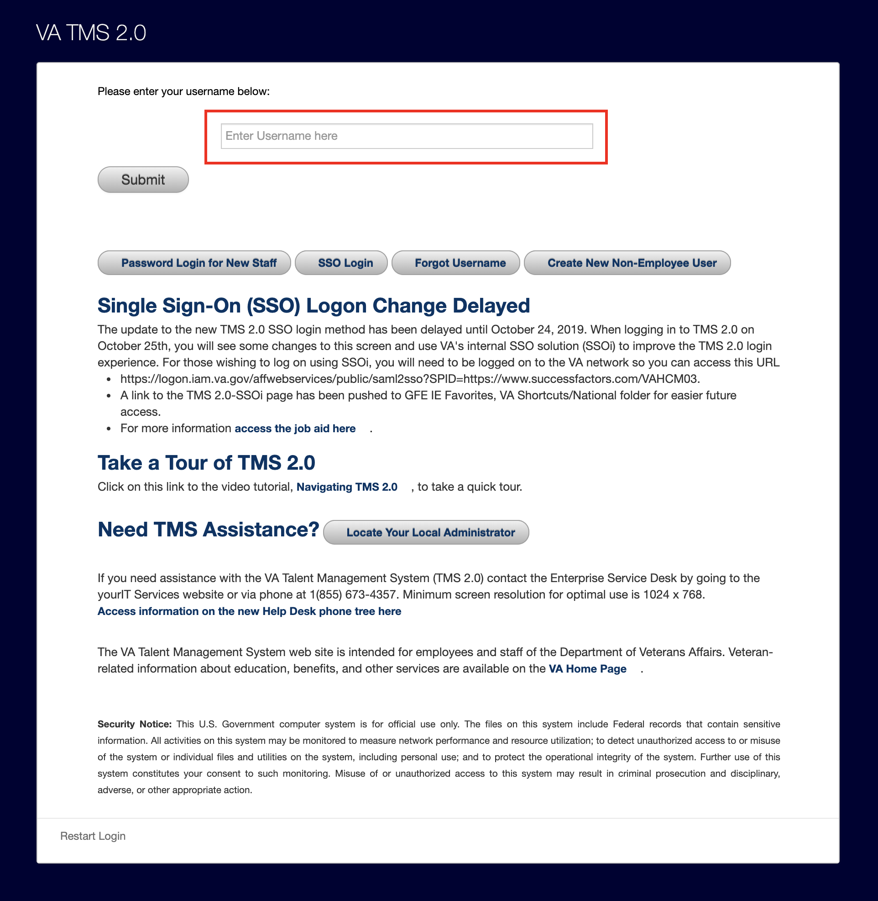
* Send you a notification to get fingerprinted at your local VA office ([appointments](https://va-piv.com/))
* Get you a Zoom account

# Before your e-QIP…

Before you receive and submit your e-QIP paperwork, the work on the project you can do is somewhat limited --- but, there are things you can start digging into!

### Meetings

#### 1:1s to have

Expect each of the practice area leads for this program to set a 1:1 during your first two weeks:

* [Engineers] Eng Lead (Joe Costa)
* [Product] Product Lead (Mickin Sahni)
* [Design] Design Lead (Shawna Hein)

You should also meet with your Product Manager/Lead and meet members on your team.

Team Meetings

Your calendar should have the following meetings on it (times EST):

* VA Team Watercooler (monthly, time TBD)
* VSA Retro (TBD)
* VSA End-of-Sprint Demo (bi-weekly, T @ 3:00PM)
* [Engineering] VSA Engineering Meeting (bi-weekly, T @ 2:30PM)
* [Design] Design / Research / Content / Patterns sync (weekly, M @ 1-2pm ET)
* [Product] Product Team Sync (weekly, W @ 3p ET)

### Program Documentation

These links are core to how we operate the program on a sprint-to-sprint basis.

* [Request Access to Central VSA documentation](https://drive.google.com/drive/u/0/folders/0ACZ1e6Rs_6sDUk9PVA)
  + Links to the products worked on VSA.
* Getting started documentation
  + VSP Mission, Objectives, and Roadmap (TBD)
* Team Sprint Objectives (TBD)
  + High-level objectives, organized by team, for each two-week sprint
* [ZenHub](https://github.com/department-of-veterans-affairs/vets.gov-team/blob/082770f6413561403397a7c98f3d6c842465530a/Administrative/Archive/zenhub%20description.md) Basics
  + [VSA Zenhub Board](https://app.zenhub.com/workspaces/vft-59c95ae5fda7577a9b3184f8/board?labels=dragons&notFullScreen=false&repos=33202667,62409417,31788863&showPipelineDescriptions=false)
  + Lower-level task management and tracking, tied to sprint objectives
  + *See also*: [How we use ZenHub to manage our product development workflows](https://github.com/department-of-veterans-affairs/vets.gov-team/blob/master/Practice%20Areas/Product/zenhub_product_management.pdf)
* [va.gov-team GitHub repository](https://github.com/department-of-veterans-affairs/va.gov-team)
  + Documentation + general team stuff

### Do these things during this time to ramp up

* Add the “VSA PTO” calendar.
  + [VSA PTO Calendar](https://calendar.google.com/calendar?cid=Z292ZXJubWVudGNpby5jb21fcmFlMnJlZjdnYjVwNjdubWN1ajJsN2VnZTBAZ3JvdXAuY2FsZW5kYXIuZ29vZ2xlLmNvbQ) (ping Luis Dimas in Slack if you do not have access)
  + When you schedule PTO on your calendar, add “VSA PTO” as a guest to your PTO calendar event.

### Additional Reading

Readings to provide extra history and context about the program, as you have time.

* [VSA Kickoff Deck](https://drive.google.com/file/d/1EVkxvJN1diChhVs-VCsEmQzyQwhI7Z_y/view?usp=sharing)
* Learn about our clients and the product (VA.gov - previously Vets.gov) that VSP supports:
  + [Vets.gov: A Modern Software Development Environment in Government](https://medium.com/the-u-s-digital-service/vets-gov-a-modern-software-development-environment-in-government-2a0ec8f0623a)
  + [Building Forms Faster on Vets.gov](https://medium.com/the-u-s-digital-service/building-forms-faster-on-vets-gov-d8619f4e9db)
  + [How a 20-year old kernel feature helped USDS improve VA’s network](https://medium.com/the-u-s-digital-service/how-a-20-year-old-kernel-feature-helped-usds-improve-vas-network-33109cbcb2e6)
  + [VA.gov relaunches as front door to benefits, services](https://fcw.com/articles/2018/10/02/redesigned-va-site-sammie.aspx)
  + Explore [VA.gov](https://www.va.gov) itself
* Read about [our Client’s perspective on Product Management in government](https://medium.com/the-u-s-digital-service/the-importance-of-product-management-in-government-b59933d01874)
* Read about [User Centered Design at VA](https://medium.com/the-u-s-digital-service/human-centered-design-with-americas-veterans-bcdc6c1ce50d)

# After your e-QIP is submitted

Once your e-QIP is submitted, you can get full access to work on the platform!

## Administrative

* Full access to GitHub repos

## Staging Environment

Instructions for accessing the staging environment and logging in with test users [can be found here](https://github.com/department-of-veterans-affairs/vets.gov-team/blob/635f35ad555d0cdac50667ac48c92fef2b719c64/Work%20Practices/Accessing-Staging.md)

Full list of users can be found here: <https://github.com/department-of-veterans-affairs/vets.gov-team/blob/master/Products/Identity/Login/MVI%20Integration/reference_documents/mvi_stagingUsers_fullList.csv>

This document may help find staging users that work for you:

<https://github.com/department-of-veterans-affairs/vets-api-mockdata/blob/master/mock_data_table.md>

## Tasks

* Ask **Luis Dimas** to set up your VA email account so that you can start the process for getting a PIV card (grants access to VA buildings and allows you to access the VA network)
* For Engineers: Get SOCKS proxy set up and make sure you can access [Grafana, Sentry, and Prometheus](https://github.com/department-of-veterans-affairs/vets.gov-team/blob/master/Practice%20Areas/Engineering/Internal%20Tools.md) (other disciplines may do this as needed or if inclined)
* Try accessing and exploring the [staging VA.gov site](https://github.com/department-of-veterans-affairs/vets.gov-team/blob/635f35ad555d0cdac50667ac48c92fef2b719c64/Work%20Practices/Accessing-Staging.md) using the staging user(s)

### Sharing Documents

*NOTE: At this time, our VA clients do not have access to Google Apps (e.g. Google Docs, Sheets, Slides) so all files have to first be converted to .docx, .xls or other formats before sharing.*

### Slack Channels

*NOTE: be aware that Government Slack logs can be requested via* [*FOIA*](https://www.foia.gov/about.html) *requests. (TLDR; don’t Slack things you wouldn’t want the public to see, and don’t speak negatively of or share complaints about the client.)*

## Readings

* [Presenting work to stakeholders](https://github.com/department-of-veterans-affairs/vets.gov-team/blob/9fd4d5da296a4570fd10e7a6643c8418020c97c0/Practice%20Areas/Design/Documentation%20and%20Readouts/presenting-work-to-stakeholders.md): audiences come with uneven knowledge, set the table
* [Sharing your screen](https://github.com/department-of-veterans-affairs/vets.gov-team/blob/master/Administrative/remote-work/sharing-your-screen.md): we do a lot of this, learn from our mistakes!
* [10-minute “Hello World” GitHub Guide](https://guides.github.com/activities/hello-world/): for those who are new to GitHub

# **Design**

These are the folks (excluding DSVA folks) on the design team:

* **Shawna Hein** (Ad Hoc, California) - VSA Design Lead (cross-team)
* **Jennifer Strickland** (Ad Hoc, DC Area) - Accessibility Designer (cross-team)
* **Arthur Green** (GCIO) - Designer / Researcher on Authenticated Experience
* **Carolyn Williams** (Ad Hoc, Maryland) - Designer / Researcher on Disability, Benefits, Appeals
* **Kevin Stachura** (GCIO, Michigan) - Designer / Researcher on Disability, Benefits, Appeals
* **Aricka Lewis** (Ad Hoc, Arkansas) - Designer / Researcher on Facility Locator
* **Jim Adams** (GCIO, Florida) - Designer / Researcher on eBenefits
* **Riley Orr** (Amida, DC Area) - Designer / Researcher on Disability, Benefits, Appeals 2
* **Becca Walsh** (Ad Hoc, Florida) - Designer / Researcher on Disability, Benefits, Appeals 2

## **Slack Channels**

Please make sure you are in the following channels:

On Ad Hoc / GCIO shared Slack

* #va-vsa
* #va-vsa-ux

On DSVA Slack

* #vsa
* #design
* #design-system
* #vetsdotgov-research
* #feedback-backchannel
* Your team specific channel (e.g. #vsa-ebenefits, #vsa-global-ux, #vsa-authd-exp, or #vsa-benefits-memorial, #vsa-caregiver)

## **Meetings to know about**

* Weekly 1:1s with Shawna
* Monday 10am PST / 1pm EST VA.gov Platform and Apps Weekly Design + Content + Research Sync
* Wednesday 12:30 PST/ 3:30 EST VSA Weekly UX Meeting

## **Things to do/read to get you up and running with our program**

### Design

#### Tools

We tend to use Mural, Sketch, and InVision. Let Shawna know if you don’t have access to these tools.

#### Design Reviews

See the [Design Review process doc](https://github.com/department-of-veterans-affairs/va.gov-team/blob/master/teams/vsa/design/vsa-design-review-process.md) for how to have designs reviewed

#### Resources

Resources are also pinned to the #va-vsa-ux channel.

* DSVA’s design folder <https://github.com/department-of-veterans-affairs/vets.gov-team/tree/master/Practice%20Areas/Design>
* DSVA’s onboarding document <https://github.com/department-of-veterans-affairs/vets.gov-team/blob/master/Practice%20Areas/Design/NewDesigners/UXOnboarding.md>
* Style Guide - <https://design.va.gov/design/>
* VA Digital Services handbook <https://department-of-veterans-affairs.github.io/va-digital-service-handbook/>
* Content Style Guide - <https://design.va.gov/content-style-guide/>
* Information about the design system -<https://github.com/department-of-veterans-affairs/vets.gov-team/blob/master/Practice%20Areas/Design/Design%20System/design-system-summary.md>
* Sketch file with elements - <https://github.com/department-of-veterans-affairs/vets.gov-team/blob/master/Practice%20Areas/Design/Design%20Resources/Pattern%20Library/VA-gov-Pattern-Library.sketch>

### Research

Please read the [comprehensive guide about conducting research on VSA](https://docs.google.com/document/d/1d2PJ6saIhzbWneevUs4rc153LTcbGxN-IJ9cXT51g1A/edit#).

# **Engineering**

## **Slack Channels**

Please make sure you are in the following channels:

On Ad Hoc / GCIO shared Slack

* #va-vsa

On DSVA Slack

* #vsa-engineering
* Your team specific channel (e.g. #vsa-ebenefits, #vsa-global-ux, #vsa-authd-exp, or #vsa-benefits-memorial, #vsa-caregiver, #vsa-caregiver-engineering)

## **Meetings to know about**

* Weekly 1:1s with Joe or Nick
* Bi-weekly engineering team meeting (Tue @ 230p ET)

## **Things to do/read to get you up and running with our program**

### **Setting Up Your Environment**

All instructions for setting up your local environment can be accessed via GH in the [Getting Started](https://github.com/department-of-veterans-affairs/va.gov-team/blob/master/Practice%20Areas/Engineering/getting-started.md) doc

# **Product**

These are the folks (excluding DSVA folks) on the design team:

* **Mickin Sahni** (Ad Hoc, DC) - VSA Product Lead (cross-team)
* **Kara Kemalhi** (Ad Hoc, Baltimore) - Product on Global UX & Content
* **Justin Pickett** (GCIO, Austin) - Product on Authenticated Experience
* **Yana Roy** (GCIO, New Jersey) - Product on Disability, Benefits, Appeals
* **Scott Yaroschuk** (GCIO, Virginia) - Product on Caregiver Discovery Sprint
* **Jason Wolf** (GCIO, Virginia) - Product on eBenefits

## **Slack Channels**

Please make sure you are in the following channels:

On Ad Hoc / GCIO-shared Slack

* #va-vsa
* #va-vsa-product

On DSVA Slack

* Your team specific channel (e.g. #vsa-ebenefits, #vsa-global-ux, #vsa-authd-exp, or #vsa-benefits-memorial, #vsa-caregiver)

## **Meetings to know about**

* Weekly 1:1s with Mickin
* Weekly Sprint Ceremonies
* Weekly Product Sync - Wednesday 3-3:30p ET
* Team of Teams (TOT) - Tuesday 12-12:50p ET